OnLine Transactional Processing (OLTP)

CRUD VS OLTP

CRUD

Processing against a **single** record.

Record maintenance: Add, Update, Delete

It is a transaction, a single record transaction

Processing can include business rule(s) before the action

Example: no duplicate

Certification requirements

OLTP

Processing against **multiple datastores** in one transaction

Datastore: a record, a Table, a database

Processing: Add, Update, or Delete

It is a transaction: one or more records on one or more tables

As a transaction: it is ALL or Nothing

Processing can include business rule(s) before the action

Example: no duplicate

Certification requirements

**Further processing depends on previous processing within the transaction process.**

Transaction in our EntityFramework

Staging (.Add, .Update, .Remove)

Staging all local memory

.SaveChanges() which activates EntityFramework / Database processing

For a transaction there is ONE ONLY SaveChanges().

OLTP Sale Transaction

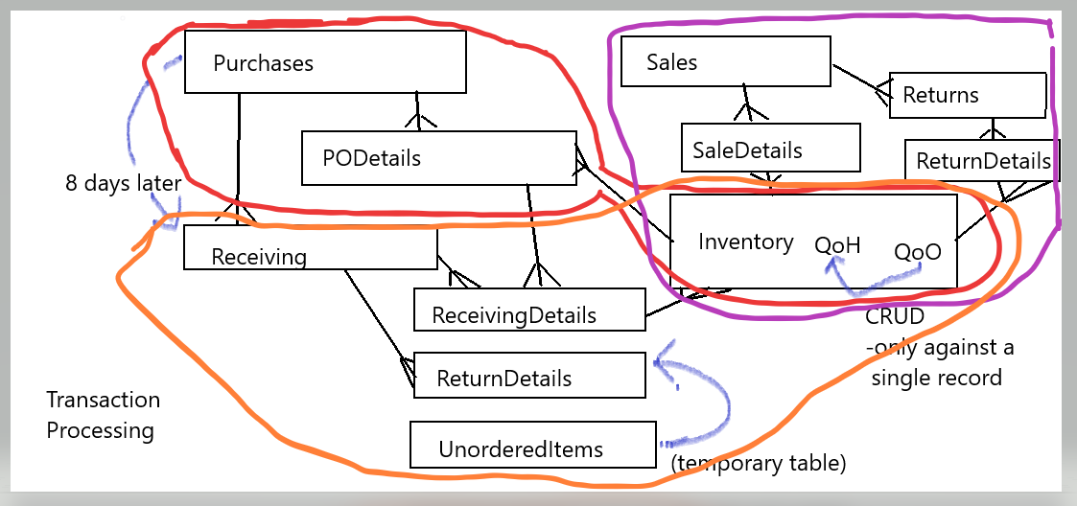

Sale transaction

Record the sale 1 Add

Record the details of the sale (n items Add)

Record changes in inventory (n items Update)

.SaveChanges() commit the transaction

Sale: saleid, date, employee, subtotal, gst

SaleDetail: saledetailid, saleid (fkey), item#, quantity, price

Inventory: item#, quantityonhand, price